**Cyclical infection dynamics in bat reservoir and human behavior drive seasonal Nipah virus encephalitis outbreaks in Bangladesh**

Jonathan H. Epstein1, 7*, Simon J. Anthony4, A. Marm Kilpatrick2, Ariful Islam1, Shahneaz Ali Khan1,3, Maria Sanchez4, Jennifer Barr6, Ina Smith6, Carlos Zambrana-Torrelio1, Yun Tao1, Ausraful Islam5 , Phoenix Lan Quan4, Kevin J Olival1, Emily Gurley5, M. Jahangir Hossein5,Hume. E. Field1, Mark D. Fielder7,Thomas Briese4,Mahmud Rahman8, Gary Crameri6, Lin-Fa Wang6, Stephen P. Luby5,9 , W. Ian Lipkin4, and Peter Daszak1

1. EcoHealth Alliance, New York, New York, USA

2. University of California, Santa Cruz, California, USA

3. Chittagong Veterinary and Animal Science Univetrsity, Chittagong, Bangladesh

4. Center for infection and Immunity, Columbia University, New York, New York, USA

5. International Centre for Diarrheal Diseases Research, Bangladesh, Dhaka, Bangladesh

6. CSIRO Australian Animal Health Laboratory, Geelong, VIC, AUS

7. School of Life Sciences, Science, Engineering and Computing Faculty, Kingston University, London, UK.

8. Institute of Epidemiology, Disease Control & Research, Government of Bangladesh, Dhaka, Bangladesh

9. Stanford University, Stanford California, USA

*Corresponding author.

**Introduction**.

Outbreaks of zoonotic pathogens are sporadic, often rare events that can have devastating consequences and are inherently difficult to predict (1). Several emerging zoonoses have become pandemics with significant global health and economic impacts, including HIV/AIDS, SARS coronavirus, and most recently, Ebolavirus Zaire in West Africa (2-4). Understanding the ecology of a zoonotic pathogen may help predict and prevent outbreaks, but is challenging due to the complexity of the systems (e.g. one or more hosts, environmental factors, multiple mechanisms of spillover to humans) in which they typically exist. These systems frequently include wild animal reservoirs (e.g. bats, rodents, and nonhuman primates), seasonal within-host infection dynamics (e.g. Marburg virus (5)), multiple routes of transmission to people; and environmental factors that are subject to anthropogenic changes over varying time scales that may require years, if not decades of study to understand (6). Longitudinal ecological studies of zoonotic pathogens that collect field data to estimate host abundance, geographic distribution, infection status, and mechanism of pathogen transmission to other animals and people are resource intensive and therefore infrequently conducted. As a result, the ecology of many emerging zoonoses remains poorly understood, which creates an impediment to predicting the timing and location of human outbreaks and the development of effective interventions that may limit opportunities for pandemics to occur (1, 6, 7).

Nipah virus (NiV) is an emerging zoonotic paramyxovirus (genus *Henipavirus*)with pandemic potential (8). Nipah virus was first recognized in Malaysia in 1998 and has repeatedly caused outbreaks in Bangladesh and India with mean mortality rates around 70% (9-11). Old world frugivorous bats, particularly those species within the genus *Pteropus* (Family *Pteropodidae*)*,* are the reservoir hosts for henipaviruses in Asia and Australia (12-20). Several characteristics give NiV the potential to cause a significant global pandemic: its bat reservoir hosts are widely distributed throughout Asia and often overlap human and livestock populations; it has the ability to be transmitted directly from bats to humans or to livestock then humans; it can be transmitted from person to person; spillover has occurred repeatedly in populous and internationally connected regions; and it is associated with a high mortality rate (21). Despite the wide distribution of henipaviruses and their bat hosts, human infections have been identified in a relatively limited number of locations: India, Bangladesh, Malaysia, The Philippines, Singapore, and Australia – a fraction of the countries where henipaviruses have been identified in bats (9, 15, 22-25). In Africa, a Nipah–like virus has been detected in *Eidolon helvum,* (also Family *Pteropodidae*) and non-neutralizing IgG antibodies against an unidentified henipavirus have been reported in human populations in Cameroon, known to hunt and eat these bats (26). However outbreaks of NiV encephalitis have not been reported in these populations.

In Malaysia and Singapore, most human NiV cases during the original outbreak in 1997-98 resulted from exposure to infected pigs (23, 27). Ecological investigations found that NiV circulated widely in both endemic pteropid bat species (28). Nipah virus is shed in bat urine, saliva, and feces (12, 29, 30). Fruit trees planted next to pig enclosures on the index farm created an interface that allowed bats to drop saliva- (and presumably NiV) contaminated fruit and other excreta into the enclosures, which could be eaten by pigs (31). The industrialization and intensification of pig farming created the conditions that allowed persistent circulation within pigs and the outbreak to occur (32, 33).

In Bangladesh, outbreaks of NiV encephalitis have been recognized in people on a near-annual basis since 2001, with a mean case fatality rate of 70% and in some cases reaching 100% (11, 34). Outbreaks in Bangladesh are seasonal and spatially clustered within the western part of the country (11). The consumption of raw date palm sap is a significant risk factor associated with NiV infection (35, 36). *Pteropus giganteus* is the only pteropid bat present on the Indian subcontinent, and antibodies against NiV as well as viral RNA have been reported in individuals of this species, making it a putative reservoir (13, 15, 37). *Pteropus giganteus* feeds on date palm sap as it flows into collection pots overnight and contaminates the sap with excreta and occasionally Nipah virus (12, 30, 38, 39). Subsequent human-to-human transmission has been observed, which accounts for the majority of total cases, though to date at least 48 primary human cases, presumed to be infected directly by bats, have been identified (8, 11).

Pteropid bats, in general, are highly adaptable to humanized environments, and often live in close association with people, as is the case in Bangladesh (40). Ecological studies of *P. giganteus* in Bangladesh, conducted by our group, showed that they prefer to roost in hardwood trees found in fragmented patches of forest within populous areas, rather than remote forests (40, 41). The timing of date palm sap harvesting (November – April) aligns with human Nipah virus encephalitis outbreaks, however, given the abundance of *P. giganteus* across Bangladesh, and the potential for other routes of transmission (e.g. via domestic animals (42)), it remains unclear why cases have not been detected outside these months or in locations beyond the Nipah Belt (with the exception of a single case in the eastern district of Comilla in 2011 (34)). We conducted a seven-year study of NiV in *P. giganteus* in Bangladesh to determine whether spatial or seasonal NiV infection patterns occur in *P. giganteus* and if so, whether they might influence human outbreaks.

**Results**

*Comparison of Nipah virus in bat populations inside and outside the Nipah Belt*

We tested a total of 883 *P. giganteus* caught from 8 different populations between January 2006 and November 2012. We detected anti-Nipah IgG antibodies in each of the bat colonies surveyed across Bangladesh (**Figure 1**). IgG seroprevalence in each colony ranged from 20% (95% CI: 10%-30%) in Rajbari to 56% (95% CI: 49%-63%) in Tangail. Seroprevalence did vary significantly among all locations (2 = 55.61, p<.001), however, there was no significant difference in seroprevalence between bats from colonies within the Nipah belt and those outside the belt (Wilcoxon Rank: w=11, p = 0.486). Age-stratified analyses of seroprevalence at each location showed that adult seroprevalence was either higher or not significantly different than juvenile seroprevalence at the time of sampling (**Figure 1**). Nipah virus RNA was detected in excreta from bats inside (Rajbari, Thakurgaon, and Faridpur) and outside (Comilla) the Nipah Belt and in months (e.g. May and June) beyond the season of human infection (Nov-Apr). Nipah virus RNA was detected in samples from individual bats in Rajbari and Thakurgaon and from pooled urine samples collected in Comilla in 2008 (**Table 1**). The estimated viral prevalence in Rajbari was 4% (95%CI +/- 11%). We could not estimate prevalence in Thakurgaon because the PCR detection was made in 3 pooled throat samples each representing 4 individuals, none of which could be resolved to an individual sample, although the findings were confirmed by sequencing. The pooled urine samples in Comilla were collected from underneath the roost and it was unknown how many bats contributed to each sample.

*Longitudinal study of Faridpur bat population*

*Mark-recapture and sero-conversion/reversion*

A total of 2345 bats from a single population in the Faridpur/Rajbari region were sampled and marked with a microchip. Between 2007 and 2012 there were 50 recapture events (**Table 2**). Fifty bats were recaptured once and of those, 6 bats were recaptured twice, giving an overall recapture rate of 2.4%. Based on the location of initial capture and subsequent recaptures, a “roost complex” was described (**Figure 2**). The roost complex is a minimal polygon, 80Km2 in area, which contains all of the roosts where bats from the Faridpur population were captured. It is assumed that there are additional roost locations used by this population of bats which were not observed. Ten instances of seroconversion (change from IgG negative to IgG positive) and 9 instances of *seroreversion* (positive to negative) were observed (**Table 2**). The mean time between positive then subsequently negative tests was 570 days (n=9) (range: 124 – 1082 days). Excluding juvenile bats that may have lost maternal antibodies between initial and secondary capture, the mean time to reversion in *adults* was 588 days (n=6) (range: 124-1082 days). There was no significant difference in observed seroconversion rates between females and males (p >.05).

*Factors associated with Nipah virus* IgG *serostatus in* P. giganteus

Among adult and juvenile bats (excluding pups; n=3206), location sampled, date sampled, age, body condition score, and mass were significant predictors of serostatus (GLM: p<.05; AIC = 3906.1; AIC = -2). Among Juvenile bats (n= 1051), location, date, quarter, mass, forearm length, and mass:forearm length ratio were significant predictors of seropositivity (GLM: p<0.05, AIC=1128.4, AIC = -2.7). Month was not significant and was removed from this model, however, when month replaces quarter, it becomes significant with a slightly higher AIC (1129.1), suggesting that month of sampling is also a significant determinant of serostatus, though not as significant as quarter. Among adult female bats (n=753), carrying a pup and body mass were significant predictors of seropositive status in the selected model (GLM: p<0.05, AIC = 862.1; AIC= -12.3). Although lactation was not significant in this GLM, it is correlated with carrying a pup, and when “PupY” was removed from the model, lactation became significant, and therefore, the overall state of lactation may be considered a significant predictor of seropositivity. Pregnancy was not a significant predictor of serostatus in this model.

Adult males (n=1320) were more likely than adult females (n=753) to have NiV antibodies (56.7% vs 45.4%; 2= 23.88 p<.001) whereas there was no sex-based difference in seroprevalence among juvenile bats (F:24.9% (n=477) vs M:27.8% (n=546) 2 = 0.94 p=0.33). Adult bats had a higher seroprevalence than juvenile bats (52.6% v 26.4%, 2 = 188.9 p<.001).

*Annual Nipah virus serodynamics in Faridpur* P. giganteus

There were significant changes in adult and juvenile seroprevalence over the study period. Adult seroprevalence ranged from 20% (95% CI: 15%-25%) to 82% (95% CI: 77%-87%). Juvenile seroprevalence ranged from approximately 0% to 44% (95%CI 37%-51%). A parameterized Susceptible-Infected-Recovered (SIR) model based on serological data from the longitudinal study in Faridpur shows that there are distinct Nipah virus infection trends in adults and juveniles. The juvenile infection pattern appears to be seasonal, with oscillations in seroprevalence that peak in approximately June or July each year for the first four years, and which then convert to a bi-annual frequency (**Figure 3**). Adult seroprevalence did not appear to have a seasonal or annual pattern. It generally declined over the course of the study. At various times within the study period, there are troughs followed by spikes (eg. September 2009-Sept 2010), which may indicate that a viral outbreak occurred within the adult population. In some cases we detected Nipah virus (e.g. May 2009, **Table 1**) preceding a peak in adult and juvenile seroprevalence. Roost count data from several roosts within the roost complex showed a generally declining population over the course of the study (**Figure 3**).

*Nipah virus RNA detection and phylogenetic analysis.*

**Table 1** shows the viral prevalence from each sample period and the individual bats from which NiV RNA was detected as well as detection in pooled urine samples. We detected Nipah virus RNA in 11 bats, 3 pooled throat samples and 21 pooled urine samples. Among individual bats, detections were made in oropharyngeal, urine, and rectal sample types. We considered detection of NiV RNA in any single sample type from a bat as indicative of infection and viral shedding. Detection rates by sample type were: oropharyngeal swab 3% (n=2088); urine/urogenital swab = 4% (n=2126); and rectal swab = 1.3% (n=79). NiV detection occurred in months both during and outside of the human Nipah virus encephalitis season, including June, July, and August, suggesting that bats are capable of shedding virus (or viral RNA) throughout the year. NiV sequences were obtained from bats within the Nipah Belt with the exception of Comilla.

Phylogenetic analysis of bat, human, and pig NiV sequences from a 224nt section of the N gene (nt position 1290-1509 [position ref [gb|FJ513078.1|](http://www.ncbi.nlm.nih.gov/nucleotide/253559843?report=genbank&log$=nuclalign&blast_rank=2&RID=E78W7PTN01R) India]) supports the findings from (43) that NiV forms two groups: sequences from Bangladesh and India (group I) cluster separately from those sequences from Malaysia and Thailand (group II) (**Figure 4A**). NiV sequences from bats in Thailand (*Pteropus lylei*) fell within both groups, indicating a broad diversity of sequences within this species. Analysis of complete N gene sequences (1655nt) from bats, pigs, and humans, including N gene sequences obtained from *P. giganteus* in this study, showed a similar relationship as seen with the 224nt sequences (Suppl. Data, Fig Xa). Eleven of 19 224nt N gene sequences obtained from bats between 2006 and 2012 (all from the same population) were identical. Overall, the N gene sequences identified from the Faridpur population (which includes Rajbari and Bhanga) between 2006 and 2011 had 98.21%-100% nucleotide homology, showing relative stability over a five-year period within this gene region. Sequences from Rajbari district obtained in January 2006 and January 2011 had only a single nucleotide difference – a synonymous substitution (G to A) at position 1304, which was found in 4 other bat sequences from this study, as well as in the NiV isolate from *P.vampyrus* in Malaysia. Additionally, analysis of available G and P gene sequences were also consistent with the relationships seen with the N gene (**Figure 4B-C**) and support our phylogenetic analysis of the shorter N gene sequence. Human NiV N gene sequences collected from people in various locations within the Nipah Belt over the same time period as our study show more nucleotide diversity than those from the single *P.giganteus* population. By contrast, the sequences found in Comilla, a location 150Km to the east of the Faridpur population, showed 80.8%-82.59% homology to sequences from *P. giganteus* in Faridpur and clustered within the Malaysia group of NiV sequences. The two Comilla sequences were identical to each other, and had up to 87.95% homology to sequences in *P. lylei* in Thailand.

*Bat movement ecology*

Home range analysis of the satellite telemetry data showed that bats tended to stay close to the roost site where they were collared and that any excursions made were short in distance. The majority of bat locations obtained from bats in Faridpur were within 10km of the bat’s initial point of capture. In Cox’s Bazaar, most bats stayed within 7km of the roost where they were initially captured. Homerange analysis showed that bats in Faridpur and Cox’s Bazar are distinct populations with effectively no (< 5%) probability of intermingling (**Figure 5**). Similarly, there is a <5% probability of bats moving between the Faridpur and Comilla bat colonies, which are 140km apart, although it is possible. The longest distance between two locations recorded for any of the bats was 317km (a roost within the Fairdpur complex and a location in Mizoram, India). The average foraging radius from roost sites was…

**Discussion**

We combined ecological, epidemiological, and molecular virology approaches to characterize Nipah-virus-bat host dynamics in Bangladesh. Our findings of NiV exposure and infection in bats over space and time confirm that *Pteropus giganteus* is a natural reservoir for Nipah virus, which was suggested by previous studies (13, 15, 44, 45). We found that Nipah virus circulates widely in *P. giganteus*, which is consistent with other studies of henipavirus serology in flying foxes in Malaysia and Australia (28, 46, 47). While we observed variation in seroprevalence based on location, the likelihood of a bat carrying Nipah virus did not depend on whether or not it was inside the Nipah Belt, which addresses the question of whether the spatial clustering of human cases may be related to higher incidence of disease in bats in western Bangladesh. As with pteropid bat reservoirs in Malaysia (48), Nipah virus RNA was found in a very low proportion of *P. giganteus* (1-4%) which is unsurprising given that Nipah virus has been shown to be an acute infection, cleared by bats within 10-14 days (29, 30). Most of the Nipah virus sequences obtained came from urine samples, though NiV RNA was also detected in oropharyngeal and rectal swabs, indicated that there are multiple routes of shedding possible. Importantly, we detected Nipah virus in bats at times outside of the season when human infections have occurred (e.g. May, June, and August), indicating that bats may be infected and shed virus year-round. This was also found to be the case with Hendra virus in Australia (46). While several studies have detected henipavirus RNA in pooled roost urine *(**20**,* *46**,* *49**,* *50**)*, this is the first study to describe viral strain variation in individual bats over space and time. We found a broad diversity of Nipah virus genotypes in Bangladesh correlated with geography. While the effect of genetic diversity on phenotype is unknown, the possibility that pathogenicity varies with genotype is supported by the existence of Cedar virus, a non-pathogenic henipavirus (51) as well as ebolavirus Zaire and Reston (highly pathogenic and non-pathogenic, respectively (52)). The Malaysian and Bangladesh strains of Nipah virus have been shown to replicate to different degrees in the oropharynx, which may affect transmissibility (53). The majority of bat NIV sequences we found clustered within the India/Bangladesh group of NiV previously described (43). However, it was notable that a highly divergent sequence was found in the eastern region that clustered with the Thailand/Malaysia group. This suggests that there is likely to be mixing between *P. giganteus* populations in eastern Bangladesh and bats in Myanmar, where this species likely also overlaps with *P. lylei(**54**).*  Clearly, more sequences are needed from bats in different parts of Bangladesh (and India and Myanmar) to develop a better picture of the continuum of Nipah virus genotypes. The observation that human sequences from various locations showed more diversity than NiV sequences from bats in one location over the same time period suggests that there may be locally prevalent genotypes that persist over time in bat colonies, and the genotypes of human outbreaks reflect the local strain present in bats at the time of spillover. Examination of sequences collected from bats and humans contemporaneously during an outbreak will help test this hypothesis.

Our SIR model of serodynamics the Faridpur population indicate that juvenile bats drive seasonal patterns of infection, with annual to every two-year peaks of infection occurring around June or July and troughs in December. This is significant because the peak period of human infection by bats (December/January) occurs at a time when there may be the fewest bats infected. If a mechanism for spillover was present during the summer months, when date palm sap is not typically harvested, there is the potential for more frequent human infections and potentially larger outbreaks. Although the epidemiological evidence strongly supports date palm sap consumption as the most important risk factor for infection, it is surprising that there haven’t been human cases reported outside of date palm sap season. Domestic animals may play a role in human infection. Outbreak investigations from 2001, 2003, and 2004 found exposure to a sick cow, sick goats, and a nomadic pig herd was a risk factor for infection (15, 55). Previously, we found anti-NiV but non-neutralizing antibodies in cattle, goats, and pigs in Bangladesh, suggesting spillover has occurred (56). While no livestock disease outbreaks have been linked to Nipah virus in Bangladesh, domestic animals foraging on, or being fed, bitten fruit found on the ground more experience elevated rates of morbidity and mortality (57). It is plausible that dropped fruit are contaminated by bat excreta and that this may be a route of NiV transmission from bats to livestock (11, 57). This is likely how pigs in Malaysia were initially infected, and it is how Hendra virus is believed to infect horses that graze underneath trees visited by pteropid bats (31, 58).

One explanation for the timing of human infections despite lower infection rates in bats may be that food sources for bats in the winter months are scarce compared to spring and summer, when fruit is more abundant, so bat foraging activity may be concentrated around date palm sap collection pots. Whereas, in the summer, more bats may be infected, but they are feeding on figs and a variety of cultivated fruit, which may dilute the overall likelihood of spillover via foodborne routes.

*Movement Ecology*

The mark-recapture study and the satellite telemetry study significantly increase our understanding of local and long-range movements of *P. giganteus* and Nipah virus dynamics*.* Local movement patterns have been described in other pteropid species using radio, satellite, and GPS telemetry (59-62), however, our characterization of a “roost complex” provides some context as to how a population may be defined for the purpose of ecological, genetic, or epidemiologic studies. The observation of local shifting supports the *a priori* assumption we made that bats sampled from nearby roosts, which was sometimes necessitated by the absence of bats at a study site, could be considered part of the same population.

Satellite telemetry showed that *P. giganteus’* movements appear to be highly localized, with bats tending to stay within a 7-10km radius of their roost. This is different than what we observed in *P. vampyrus* in Malaysia or *Acerodon jubatus* in the Philippines, where much longer flight distances and home ranges were observed (63, 64). The estimated home ranges for the two groups of *P. vampyrus*  tracked in Malaysia were 64,000km2 and 128,000km2, significantly larger than the xxkm2 and YYkm2 for *P. giganteus* in Bangladesh (63). Pteropodid bat migration is primarily driven by food resource availability (59, 65, 66). Pteropid bats in Malaysia forage on wild *Ficus spp*. and other fruits and flowers, which are seasonally available, but they will exploit cultivated crops at times when wild forage is less available (67). Bangladesh has a significantly less forest cover than Malaysia, presumably due to a greater human population density and land use. Hahn et al. observed that *P. giganteus* in Bangladesh prefer to roost in humanized environments, with more forest fragmentation (41). This may be due to the fact that there is generally cultivated fruit and roosting habitat readily available in villages, and villages comprise the majority of the landscape across Bangladesh. Many towns and villages have *P. giganteus* roosts, and they are generally well tolerated (Epstein, unpublished obs.). As in Malaysia, flying foxes are hunted and eaten in Bangladesh, but hunters use nets rather than guns, which is less likely to cause the evacuation of roosts. The pervasive practice of hunting flying foxes for sport and food in Malaysia likely contribute to the transience of many roosts and the presence of less easily accessible roosts deep within the forest (63).

Movement patterns observed in *P. giganteus* support some degree of connectivity among colonies within a given radius, as seen with other members of *Pteropus (**59**,* *63**,* *64**,* *68**,* *69**)*. A metapopulation structure creates connectivity among susceptible bats across the larger landscape, supporting persistence of henipaviruses even at low incidence, as suggested by Plowright et al. (70). The more sedentary nature of *P. giganteus* coupled with an acute infectious period for Nipah virus may create a more patchy landscape of viral dynamics across bat populations in Bangladesh and may explain the spatial diversity seen in disparate populations (Faridpur vs. Comilla) and by proxy, in human cases from different localities (70). We acknowledge that the limited number of sequences detected, and the relatively short region of the N gene used for phylogenetic analysis doesn’t allow us to rule out that there are diverse strains co-circulating in Faridpur, or that the diversity in human NiV sequences might simply be a reflection of mutation that occurred when the virus jumped from bats to humans.

Connectivity among bats may not be necessary to maintain Nipah virus within colonies. Persistently infected individuals that experience recrudescence intermittently could trigger an outbreak if seroprevalence in a population was low enough to limit the protective effect of herd immunity. Nipah virus recrudescence, has been observed in *Pteropus vampyrus* (71).We observed the loss of IgG antibodies in individual recaptured bats, as well as a gradual decline in seroprevalence in Faridpur, which suggest that immunity to Nipah virus is not life-long in *P. giganteus.* Had our study continued, we would expect that eventually adult seroprevalence would drop below a threshold after which a large outbreak could occur, causing a spike in seroprevalence. This may have occurred after 2006, when we first sampled the Faripur/Rajbari population and found a 20% seroprevalence in both adults and juveniles. The next sample from this population was in 2007 and seroprevalence doubled in juveniles and nearly quadrupled in adults (**Figure 3**). Another instance of the adult population dropping below a protective threshold of immunity may have occurred between February and May 2009, when adult seroprevalence dropped from 68% to 48%, while juvenile seroprevalence rose from 24% to 37%. During that period, we also detected NiV RNA in an adult bat sampled in February 2009 and two more adult bats in May 2009 (**Table1**), suggesting that Nipah virus was circulating within the colony during this period. Coincidently, we also observed sero-conversion in an adult bat that was IgG-negative in December 2008 and then IgG-positive in May 2009 (**Table2**). By November 2009, the adult seroprevalence peaked at 76% and the juvenile seroprevalence peaked at 44%.

*Conclusion*

Our multi-faceted study provides a clearer understanding of host-virus infection dynamics for Nipah virus in Bangladesh, which are seasonal and cyclical. Bats are infected year-round, but the primary interface that promotes spillover into people is not available in the summer months when Nipah virus incidence peaks in *P. giganteus*. Henipavirus infection in cows, goats and pigs may not be detected due to lack of surveillance (72). While hospital based surveillance systems would likely identify human cases at any time of year, surveillance of livestock for Nipah virus infection should be conducted, particularly during the summer months when transmission peaks among bats and dropped fruit may be a mechanism for transmission to livestock, as this may still constitute a risk for human infection.

Similar seasonal henipavirus dynamics may also occur in other pteropodid bat hosts, and the presence or absence of a human-bat interface may influence the current geographic pattern of human infection. This study highlights the need to investigate the effect of viral genotype on pathogenicity and transmissibility, as there is likely a broad spectrum of Nipah-like viruses both within Bangladesh, and throughout the range of Old World fruit bats, some of which may be spilling over undetected. The question remains as whether or not spillover is occurring in regions where pteropodid bats, henipaviruses, and people co-exist, such as Nepal, Indonesia, Cambodia, or parts of Africa. Identifying seasonal viral dynamics and points of contact between people, livestock and bats, and limiting opportunity for Nipah virus spillover is critical to reducing the likelihood that a more transmissible strain may emerge and cause a pandemic.

**Methods**

The overall study period was between January 2006 and November 2012. Within this time period, three different studies of *Pteropus giganteus*, with similar bat sampling protocols, are described: a cross-sectional spatial study with a single sampling event in each of the eight locations listed above; a longitudinal study of a Faripur bat population with repeated sampling approximately every 3 months from July 2007 to November 2012; and a longitudinal study of the Rajbari population with repeated sampling at a monthly interval between 12 month period between April 2010 and May 2011. Opportunistic sampling of *Pteropus giganteus* was also performed during this time period during Nipah virus outbreak investigations. These data are included here because Nipah virus testing of bat samples during these investigations supported the aims of the study. *Pteropus giganteus* were captured using mist nets at locations within eight different districts across Bangladesh between January 2006 and December 2012 (Fig 1). Locations were selected based on whether the district had any previously recorded human NiV encephalitis clusters at the time of this study (Rajbari, Tangail, Thakurgaon, and Kushtia) or whether they had not (Comilla, Khulna, Sylhet, and Chittagong) so that infection rates could be compared between regions inside and outside of the “Nipah Belt.” The Thakurgaon study was conducted as part of an NiV outbreak investigation, and coincided with ongoing human transmission (73).

*Capture and sample collection*

For the country-wide cross-sectional and Faridpur longitudinal study, we aimed to sample 100 bats at each sampling event, which lasted 7-10 days. This sample size allowed us to detect at least one exposed bat (IgG antibody-positive) given a prevalence of 10% with 95% confidence. Bats were captured using a custom made mist net of approximately 10mx15m suspended between bamboo poles which were mounted atop trees close to the target bat roost. Catching occurred between 11pm and 5am as bats returned from foraging. To minimize bat stress and chance of injury, nets were continuously monitored and each bat was extracted from the net immediately after entanglement. Bats were placed into cotton bags (pillow cases) and held for a maximum of 6 hours before being released at the site of capture. Bats were sampled at the site of capture using a field lab setup. Bats were anesthetized using isoflurane gas (74) and blood, urine, oropharyngeal swabs were collected. For some sampling periods, rectal swabs were collected but due to resource constraints, these samples were deemed to likely be lower yield than saliva and urine for NiV, and therefore were not collected consistently. For each bat sampled we recorded age, weight, sex, physiologic and reproductive status, and morphometric measurements as described previously (13). Bats were classified as either juveniles (approximately six months - the age by which most pups are weaned) to two years old (the age when most *Pteropus* species reach sexual maturity) or adults (sexually mature) based on body size and the presence of secondary sexual characteristics, pregnancy, or lactation - indicating reproductive maturity (13, 75).

Up to 3.0 mL of blood were collected from the brachial vein and placed into serum tubes with serum clot activator (Vaccutainer, USA). Blood tubes were stored vertically on ice packs in a cold box and serum was allowed to separate overnight. Serum was drawn from the tube after 24 hours and placed in a screw-top cryovial (Corning, USA) and stored in a liquid nitrogen dewar (Princeton Cryogenics, NJ, USA). Sterile pediatric swabs with polyester tips and aluminum shafts were used to collect urogenital and rectal samples, and larger polyester swabs with plastic shafts (Fisher, USA) were used to collect oropharyngeal samples. All swabs were collected in duplicate, with one set being placed individually in cryotubes containing lysis buffer (either tri-reagent or NucliSENS Lysis buffer, Biomerieux, France) or viral transport medium. All tubes were stored in liquid nitrogen in the field then transferred to a -80C freezer.

During each sampling event, pooled urine samples were collected beneath bat roosts using polyethylene sheets (2’ x 3’) distributed evenly under the colony between 3AM and 6AM. Urine was collected from each sheet either using a sterile swab to soak up droplets, or a sterile disposable pipette. Swabs or syringed urine from a single sheet were combined to represent a pooled sample. Each urine sample was divided in half and aliquoted into lysis buffer or VTM at an approximate ratio of 1 part sample to 2 parts preservative.

Sera from the cross-sectional survey were heat inactivated at 56oC for 30 minutes as described (76) prior to shipment to the Center for Infection and Immunity at Columbia University (New York, USA) for analysis. Sera from two longitudinal studies were sent to the Australian Animal Health Laboratory and were gamma irradiated upon receipt.

Lab analysis: serology

Serum samples from the cross-sectional study were screened for anti-Nipah virus IgG antibodies using an enzyme linked immunosorbant assay (ELISA) as described in (13). For the longitudinal studies, because of the large sample size and development of a high throughput multiplex assay of comparable specificity and sensitivity, we used a Luminex assay to detect anti-Nipah IgG antibodies reactive to a purified NiV soluble G protein reagent (56).

Total nucleic acids from swabs and urine samples were extracted and cDNA synthesized using Superscript III (Invitrogen) according to manufacturer’s instructions. A nested RT-PCR and a real-time assay targeting the N gene were used to detect Nipah virus RNA in samples (50). Samples with NiV RNA detected by real time PCR were confirmed by gel electrophoresis and product sequencing. A subset of NiV-positive samples were processed by high-throughput sequencing (HTS) on the Ion Torrent PGM platform in order to obtain additional NiV genomic sequence. Libraries were prepared according to the manufacturer’s instructions, and 1 million reads allocated per sample. HTS reads were aligned against host reference databases to remove host background using bowtie2 mapper, and host-subtracted reads primer trimmed and filtered based on quality, GC content and sequence complexity. The remaining reads were de novo assembled using Newbler (v2.6) and mapped to the full length NiV genome. Contigs and unique singletons were also subjected to homology search using MegaBlast against the GenBank nucleotide database, in case variance in parts of the genome precluded efficient mapping. From these data, N, P, and G gene consensus sequences were constructed using Geneious v 7.1, and used for phylogenetic analyses.

*Phylogenetic analysis*

All *P. giganteus* NiV sequences have been submitted to Genbank [accession #s XXXX]. Sequence alignments were constructed using ClustalW in Geneious v7.1 software (77). Phylogenetic trees of NiV N-gene, P-gene, and G-gene sequences were constructed using Neighbor-Joining, Maximum-Likelihood algorithms in MEGA v. 5 (78) and figures constructed in FigTree 1.4.2.

Lab analysis: molecular

Nucleic acids were extracted from swab and urine samples using MagMAX 96 Viral RNA Extraction Kit (Thermofisher) and cDNA synthesized using Superscript III (Invitrogen) according to manufacturer’s instructions. A nested RT-PCR and a real-time assay targeting the N gene were used to detect Nipah virus RNA in samples (50). A RT-qPCR designed to detect the nucleocapsid gene of all known Nipah virus isolates was also utilized (79). Oligonucleotide primers and probe were as described in the manuscript. Assays were performed using AgPath-ID One-StepRT-PCR Reagents (Thermofisher) with 250 nM probe, 50 nM forward and 900 nM reverse primers. Thermal cycling was 45◦C for 10 min, followed by 45 cycles of 95◦C for 15 s and 60◦C for 45 s. Cut-off values were cycle threshold (CT) ≤40 for positive and CT ≥45 for negative. Results with CT values between 40 and 45 were deemed indeterminate, i.e. not conclusively positive or negative. Samples with NiV RNA detected by real time PCR were confirmed by gel electrophoresis and product sequencing. A subset of NiV-positive samples were run on the Ion Torrent platform in order to obtain additional genomic sequence (ref).

Accession numbers: [to be entered once submitted].

*Satellite telemetry and homerange analysis*

We developed a collar system to attach 12g solar-powered Platform Terminal Transmitters (Microwave Telemetry, Colombia, MD, USA) to adult bats using commercial nylon feline collars with the buckle removed and 0-gauge nylon suture to attach the PTT to the collar and to fasten the collar around the bat’s neck. Collars were fitted to the bat such that there was enough space to allow for normal neck movement and swallowing, but so that the collar would not slip over the head of the animal (**suppl. Fig XXX**). PTTs were programmed with a duty cycle of 10 hrs on, 48 hours off. Data was accessed via the Argos online data service (argos-system.org ; France). A total of 14 collars were deployed as follows: Feb 2009: 3 males, 3 females from a colony in Shuvarampur, Faridpur district; Feb 2011: 3 males, 2 females from the same colony; and April 2011 Cox’s Bazaar, 3 bats from a colony in Cox’s Bazaar, Chittagong district. Adult bats were selected based on size such that the total weight of the collar (~21g) was less than 3% of the bat’s body mass.

The individual telemetry dataset was combined for each region and its aggregate utilization distributions (UD) computed in R using package ‘adehabitHR’ (80). Colony-specific home range is represented by the *95% area enclosure of its UD’s volume (Figure xx). The volume of intersection between the colonies quantifies the extent of home range overlap. To evaluate the potential for contact with the Sylhet colony, we calculated the most likely distance moved (‘mldm’) for each sampled bat at Faridpur where the population was more intensively monitored. Movement distance was measured in kilometers with respect to a centroid location () shared by the whole colony; assuming random spatial distribution in tracking rate, we estimated its kernel density function per individual and defined mldm as the mode (Table xx).

**Statistical approach**. We used generalized linear models (GLM) with a logit link and a binomial distribution to identify predictors (age, sex, location, date sampled, quarter sampled, month sampled, forearm length, mass, mass:forearm ratio, body condition, pregnancy, lactation, or carrying a pup) influenced a bat’s serostatus. Model selection was conducted using a backward step-wise approach was used to identify the model with the lowest AIC value with a AIC > -2 from an initial model that included a maximum number of factors, depending on the model (e.g. pregnancy was only included in an adult female bat model). All regression analyses, chi-square, and binomial confidence interval calculations were performed using R.

*SIR model*

An S-I-R model, parameterized with data from field observations from this study and the published literature, was used to test for seasonal trends in seroprevalence in adult and juvenile bats. The model was run in R…

Table of parameters

**Acknowledgements**: We thank Pitu Biswas, Md. Sheikh Gofur, Abdul Hai, Salah Uddin Khan, and Craig Smith for assistance in the field, Christopher Allen, and Parviez Hosseini for technical input, Vishal Kapoor and Neil Renwick for laboratory diagnostic and technical support, to the Government of Bangladesh for permits and logistical support that made this work possible. This study was funded by an NIH NIAID award to JHE (K08AI067549) an NIH Fogarty International Center Ecology and Evolution of Infectious Diseases (EEID) award to PD (R01 TW005869) a NSF-NIH EEID award to AMK (EF-0914866), a US Agency for International Development Emerging Pandemic Threats: PREDICT program (PD, JE, AI, SA, KJO).

**Literature cited**

1. Morse SS, Mazet JAK, Woolhouse M, Parrish CR, & Carroll D (2012) Prediction and prevention of the next pandemic zoonosis. *The Lancet (British edition)* 380(9857):1956-1965.

2. World Bank. World Bank Group Ebola Response Fact Sheet. <http://www.worldbank.org/en/topic/health/brief/world-bank-group-ebola-fact-sheet>. Accessed 11/18/2014.

3. Keogh-Brown MR & Smith RD (2008) The economic impact of SARS: How does the reality match the predictions? *Health Policy* 88(1):110-120.

4. Katz I, Routh S, Bitran R, Hulme A, & Avila C (2014) Where will the money come from? Alternative mechanisms to HIV donor funding. *BMC public health* 14(1):956.

5. Amman BR*, et al.* (2012) Seasonal Pulses of Marburg Virus Circulation in Juvenile Rousettus aegyptiacus Bats Coincide with Periods of Increased Risk of Human Infection. *Plos Pathogens* 8(10).

6. Daszak P*, et al.* (2013) Interdisciplinary approaches to understanding disease emergence: The past, present, and future drivers of Nipah virus emergence. *Proceedings of the National Academy of Sciences* 110(Supplement 1):3681-3688.

7. Karesh WB*, et al.* (2012) Zoonoses 1 Ecology of zoonoses: natural and unnatural histories. *Lancet* 380(9857):1936-1945.

8. Luby SP (2013) The pandemic potential of Nipah virus. *Antiviral Research* 100(1):38-43.

9. Chadha MS*, et al.* (2006) Nipah virus-associated encephalitis outbreak, Siliguri, India. *Emerging Infectious Diseases* 12(2):235-240.

10. Chua KB*, et al.* (2000) Nipah virus: a recently emergent deadly paramyxovirus. *Science* 288(5470):1432-1435.

11. Luby SP*, et al.* (2009) Recurrent Zoonotic Transmission of Nipah Virus into Humans, Bangladesh, 2001-2007. *Emerging Infectious Diseases* 15(8):1229-1235.

12. Chua KB*, et al.* (2002) Isolation of Nipah virus from Malaysian Island flying-foxes. *Microbes and infection / Institut Pasteur* 4(2):145-151.

13. Epstein JH*, et al.* (2008) Henipavirus infection in fruit bats (Pteropus giganteus), India. *Emerging Infectious Diseases* 14(8):1309-1311.

14. Halpin K, Young PL, Field HE, & Mackenzie JS (2000) Isolation of Hendra virus from pteropid bats: a natural reservoir of Hendra virus. *Journal of General Virology* 81:1927-1932.

15. Hsu VP*, et al.* (2004) Nipah virus encephalitis reemergence, Bangladesh. *Emerging Infectious Diseases* 10(12):2082-2087.

16. Iehle C*, et al.* (2007) Henipavirus and Tioman virus antibodies in pteropodid bats, Madagascar. *Emerging Infectious Diseases* 13(1):159-161.

17. Johara MY*, et al.* (2001) Nipah virus infection in bats (order Chiroptera) in peninsular Malaysia. *Emerg Infect Dis* 7(3):439-441.

18. Rahman SA*, et al.* (2010) Characterization of Nipah Virus from Naturally Infected *Pteropus vampyrus* Bats, Malaysia. *Emerging Infectious Disease* 16(12):1990-1993.

19. Sendow I*, et al.* (2006) Henipavirus in Pteropus vampyrus bats, Indonesia. *Emerging Infectious Diseases* 12(4):711-712.

20. Wacharapluesadee S*, et al.* (2010) A Longitudinal Study of the Prevalence of Nipah Virus in Pteropus lylei Bats in Thailand: Evidence for Seasonal Preference in Disease Transmission. *Vector-Borne and Zoonotic Diseases* 10(2):183-190.

21. Epstein JH, Field HE, Luby S, Pulliam JRC, & Daszak P (2006) Nipah virus: Impact, Origins, and Causes of Emergence. *Curr Infect Dis Rep* 8(1):59-65.

22. Chua K*, et al.* (2000) Nipah virus: A recently emergent deadly paramyxovirus. *Science* 288:1432-1435.

23. Paton NI*, et al.* (1999) Outbreak of Nipah-virus infection among abattoir workers in Singapore. *Lancet* 354(9186):1253-1256.

24. Ching PKG dlRC, Sucaldito MN, Tayag E, Columna-Vingno AB, Malbas FF, et al. (2014) Outbreak of henipavirus infection, Philippines, 2014. *Emerg Infect Dis.* DOI: 10.3201/eid2102.141433.

25. Selvey L*, et al.* (1995) Infection of humans and horses by a newly described morbillivirus. *Med J Aust* 162:642-645.

26. Pernet O*, et al.* (2014) Evidence for henipavirus spillover into human populations in Africa. *Nat Commun* 5.

27. Parashar UD*, et al.* (2000) Case-control study of risk factors for human infection with a new zoonotic paramyxovirus, Nipah virus, during a 1998-1999 outbreak of severe encephalitis in Malaysia. *Journal of Infectious Diseases* 181(5):1755-1759.

28. Sohayati A. Rahman*, et al.* (2013) Risk Factors for Nipah Virus Infection among Pteropid Bats, Peninsular Malaysia. *Emerging Infectious Disease.* DOI: 10.3201/eid1901.120221.

29. Halpin K*, et al.* (2011) Pteropid Bats are Confirmed as the Reservoir Hosts of Henipaviruses: A Comprehensive Experimental Study of Virus Transmission. *American Journal of Tropical Medicine and Hygiene* 85(5):946-951.

30. Middleton DJ*, et al.* (2007) Experimental Nipah virus infection in pteropid bats (*Pteropus poliocephalus*). *Journal of Comparative Pathology* 136(4):266-272.

31. Chua KB, Chua BH, & Wang CW (2002) Anthropogenic deforestation, El Nino and the emergence of Nipah virus in Malaysia. *Malaysian Journal of Pathology* 24(1):15-21.

32. Pulliam J, H. F, Olival KJ, & HERG (Daszak) (2005) An alternative explanation of Nipah virus strain variation. *Emerging Infectious Diseases* 11:1822-1827.

33. Pulliam JRC*, et al.* (2012) Agricultural intensification, priming for persistence and the emergence of Nipah virus: a lethal bat-borne zoonosis. *Journal of The Royal Society Interface* 9(66):89-101.

34. Nipah virus outbreaks in the WHO South-East Asia Region. <http://www.searo.who.int/entity/emerging_diseases/links/nipah_virus_outbreaks_sear/en/>. Accessed May 3 2015.

35. Gurley ES*, et al.* (2007) Person-to-person transmission of Nipah virus in a Bangladeshi community. *Emerging Infectious Diseases* 13(7):1031-1037.

36. Rahman MA*, et al.* (2012) Date Palm Sap Linked to Nipah Virus Outbreak in Bangladesh, 2008. *Vector-Borne and Zoonotic Diseases* 12(1):65-72.

37. Bates PJJ & Harrison DL (1997) Sub-Order MEGACHIROPTERA: Family Pteropodidae: Old World Fruit Bats. *Bats of the Indian Subcontinent*, (Harrison Zoological Museum, Kent, England), pp 13-15.

38. Salah Uddin Khan M*, et al.* (2011) Use of Infrared Camera to Understand Bats’ Access to Date Palm Sap: Implications for Preventing Nipah Virus Transmission. *Ecohealth*:1-9.

39. Rahman SA*, et al.* (2010) Characterization of Nipah Virus from Naturally Infected Pteropus vampyrus Bats, Malaysia. *Emerging Infectious Diseases* 16(12):1990-1993.

40. Hahn MB*, et al.* (2014) Roosting behaviour and habitat selection of Pteropus giganteus reveal potential links to Nipah virus epidemiology. *Journal of Applied Ecology* 51(2):376-387.

41. Hahn MB*, et al.* (2014) The Role of Landscape Composition and Configuration on Pteropus giganteus Roosting Ecology and Nipah Virus Spillover Risk in Bangladesh. *American Journal of Tropical Medicine and Hygiene* 90(2):247-255.

42. Luby S*, et al.* (2007) Recurrent Nipah virus outbreaks in Bangladesh, 2001-2007. *American Journal of Tropical Medicine and Hygiene* 77:273.

43. Lo MK*, et al.* (2012) Characterization of Nipah virus from outbreaks in Bangladesh, 2008-2010. *Emerg Infect Dis* 18(2):248-255.

44. Rahman MA*, et al.* (2012) Date palm sap linked to Nipah virus outbreak in Bangladesh, 2008. *Vector borne and zoonotic diseases* 12(1):65-72.

45. Yadav PD*, et al.* (2012) Short Report: Detection of Nipah Virus RNA in Fruit Bat (Pteropus giganteus) from India. *American Journal of Tropical Medicine and Hygiene* 87(3):576-578.

46. Field H*, et al.* (2011) Hendra Virus Infection Dynamics in Australian Fruit Bats. *Plos One* 6(12).

47. Plowright RK*, et al.* (2008) Reproduction and nutritional stress are risk factors for Hendra virus infection in little red flying foxes (Pteropus scapulatus). *Proceedings of the Royal Society B-Biological Sciences* 275(1636):861-869.

48. Heng Thay Chong, Chong Tin Tan, Khean Jin Goh, Sai Kit Lam, & Chua KB (2003) The risk of human Nipah virus infection directly from bats (*Pteropus hypomelanus*) is low. *Neurological Journal of Southeast Asia* 8(June):31-34.

49. Smith I*, et al.* (2011) Identifying Hendra Virus Diversity in Pteropid Bats. *Plos One* 6(9).

50. Wacharapluesadee S & Hemachudha T (2007) Duplex nested RT-PCR for detection of Nipah virus RNA from urine specimens of bats. *Journal of Virological Methods* 141(1):97-101.

51. Marsh GA*, et al.* (2012) Cedar Virus: A Novel Henipavirus Isolated from Australian Bats. *Plos Pathogens* 8(8).

52. Mahanty S & Bray M (2004) Pathogenesis of filoviral haemorrhagic fevers. *Lancet Infect. Dis.* 4(8):487-498.

53. Clayton B*, et al.* (2011) Nipah Viruses from Malaysia and Bangladesh: Differences in Transmission and Pathogenesis. *Ecohealth* 7:S140-S141.

54. Nowak R (1994) *Walker’s bats of the world* (The John Hopkins University Press, Baltimore).

55. Luby SP, Gurley ES, & Hossain MJ (2009) Transmission of Human Infection with Nipah Virus. *Clinical Infectious Diseases* 49(11):1743-1748.

56. Sukanta Chowdhury*, et al.* (2014) Serological Evidence of Henipavirus Exposure in Cattle, Goats and Pigs in Bangladesh. *Plos Neglected Tropical Diseases* (in press).

57. John Openshaw*, et al.* (2016) Increased morbidity and mortality in domestic animals eating dropped and bitten fruit in Bangladeshi villages: Implications for zoonotic disease transmission. *EcoHealth* (in press).

58. Field H, McLaughlin A, & Fitzpatrick B (2011) Investigating the 'why' and 'where' of Hendra Virus Infection in Horses. *Ecohealth* 7:S86-S87.

59. Eby P (1991) Seasonal Movements of Gray-Headed Flying-Foxes, *Pteropus poliocephalus* (Chiroptera, Pteropodidae), from 2 Maternity Camps in Northern New-South-Wales. *Wildlife Research* 18(5):547-559.

60. Gumal MT (2004) Diurnal home range and roosting trees of a maternity colony of *Pteropus vampyrus* natunae (Chiroptera : Pteropodidae) in Sedilu, Sarawak. *Journal of Tropical Ecology* 20:247-258.

61. Roberts BJ, Catterall CP, Eby P, & Kanowski J (2012) Long-Distance and Frequent Movements of the Flying-Fox Pteropus poliocephalus: Implications for Management. *Plos One* 7(8).

62. Tidemann CR, Vardon MJ, Loughland RA, & Brocklehurst PJ (1999) Dry season camps of flying-foxes (Pteropus spp.) in Kakadu World Heritage Area, north Australia. *Journal of Zoology* 247:155-163.

63. Epstein JH*, et al.* (2009) Pteropus vampyrus, a hunted migratory species with a multinational home-range and a need for regional management. *Journal of Applied Ecology* 46(5):991-1002.

64. de Jong C*, et al.* (2013) Foraging Behaviour and Landscape Utilisation by the Endangered Golden-Crowned Flying Fox (Acerodon jubatus), The Philippines. *PLoS One* 8(11).

65. Fleming TH & Eby P (2003) Ecology of bat migration. *Bat ecology.*, eds Kunz TH & Fenton MB (The University of Chicago Press, Chicago), pp 156-208.

66. Richter HV & Cumming GS (2006) Food availability and annual migration of the straw-colored fruit bat (Eidolon helvum). *Journal of Zoology* 268(1):35-44.

67. Numata S, Yasuda M, Okuda T, Kachi N, & Noor NSM (2003) Temporal and spatial patterns of mass flowerings on the Malay Peninsula. *American Journal of Botany* 90(7):1025-1031.

68. Plowright RK*, et al.* (2011) Urban habituation, ecological connectivity and epidemic dampening: the emergence of Hendra virus from flying foxes (Pteropus spp.). *Proceedings of the Royal Society B-Biological Sciences* 278(1725):3703-3712.

69. Tidemann CR & Nelson JE (2011) Life expectancy, causes of death and movements of the grey-headed flying-fox (Pteropus poliocephalus) inferred from banding. *Acta Chiropterologica* 13(2):419-429.

70. Plowright RK*, et al.* (2015) Ecological dynamics of emerging bat virus spillover. *Proceedings of the Royal Society B-Biological Sciences* 282(1798).

71. Rahman SA*, et al.* (2011) Evidence for Nipah virus recrudescence and serological patterns of captive *Pteropus vampyrus*. *Epidemiology and Infection* 139(10):1570-1579.

72. Chowdhury S*, et al.* (2014) Serological evidence of henipavirus exposure in cattle, goats and pigs in bangladesh. *PLoS neglected tropical diseases* 8(11):e3302.

73. Homaira N*, et al.* (2010) Nipah virus outbreak with person-to-person transmission in a district of Bangladesh, 2007. *Epidemiology and Infection* First View:1-7.

74. Jonsson NN, Johnston, S.D., Field, H., De Jong, C, Smith, C. (2004) Field anaesthesia of three Australian species of flying fox. *The Veterinary Record* 154:664.

75. Pierson ED & Rainey WE (1992) The Biology of Flying Foxes of the Genus Pteropus: A Review. *Pacific Island Flying Foxes: Proceedings of an International Conservation Conference*, eds Wilson DE & Graham GL (US Department of the Interior Fish and Wildlife Service), pp 1-17.

76. Daniels PW, Ksiazek T, & Eaton B (2001) Diagnostic tests for Nipah and Hendra viruses. *Microbes and Infection* 3:289-295.

77. Kearse M*, et al.* (2012) Geneious Basic: An integrated and extendable desktop software platform for the organization and analysis of sequence data. *Bioinformatics* 28(12):1647-1649.

78. Drummond AJ AB, Buxton S, Cheung M, Cooper A, Duran C, Field M, Heled J, Kearse M, Markowitz S, Moir R, Stones-Havas S, Sturrock S, Thierer T, Wilson A (2011) Geneious v5.4).

79. Feldman KS*, et al.* (2009) Design and evaluation of consensus PCR assays for henipaviruses. *Journal of Virological Methods* 161(1):52-57.

80. Calenge C (2006) The package "adehabitat" for the R software: A tool for the analysis of space and habitat use by animals. *Ecological Modelling* 197(3-4):516-519.

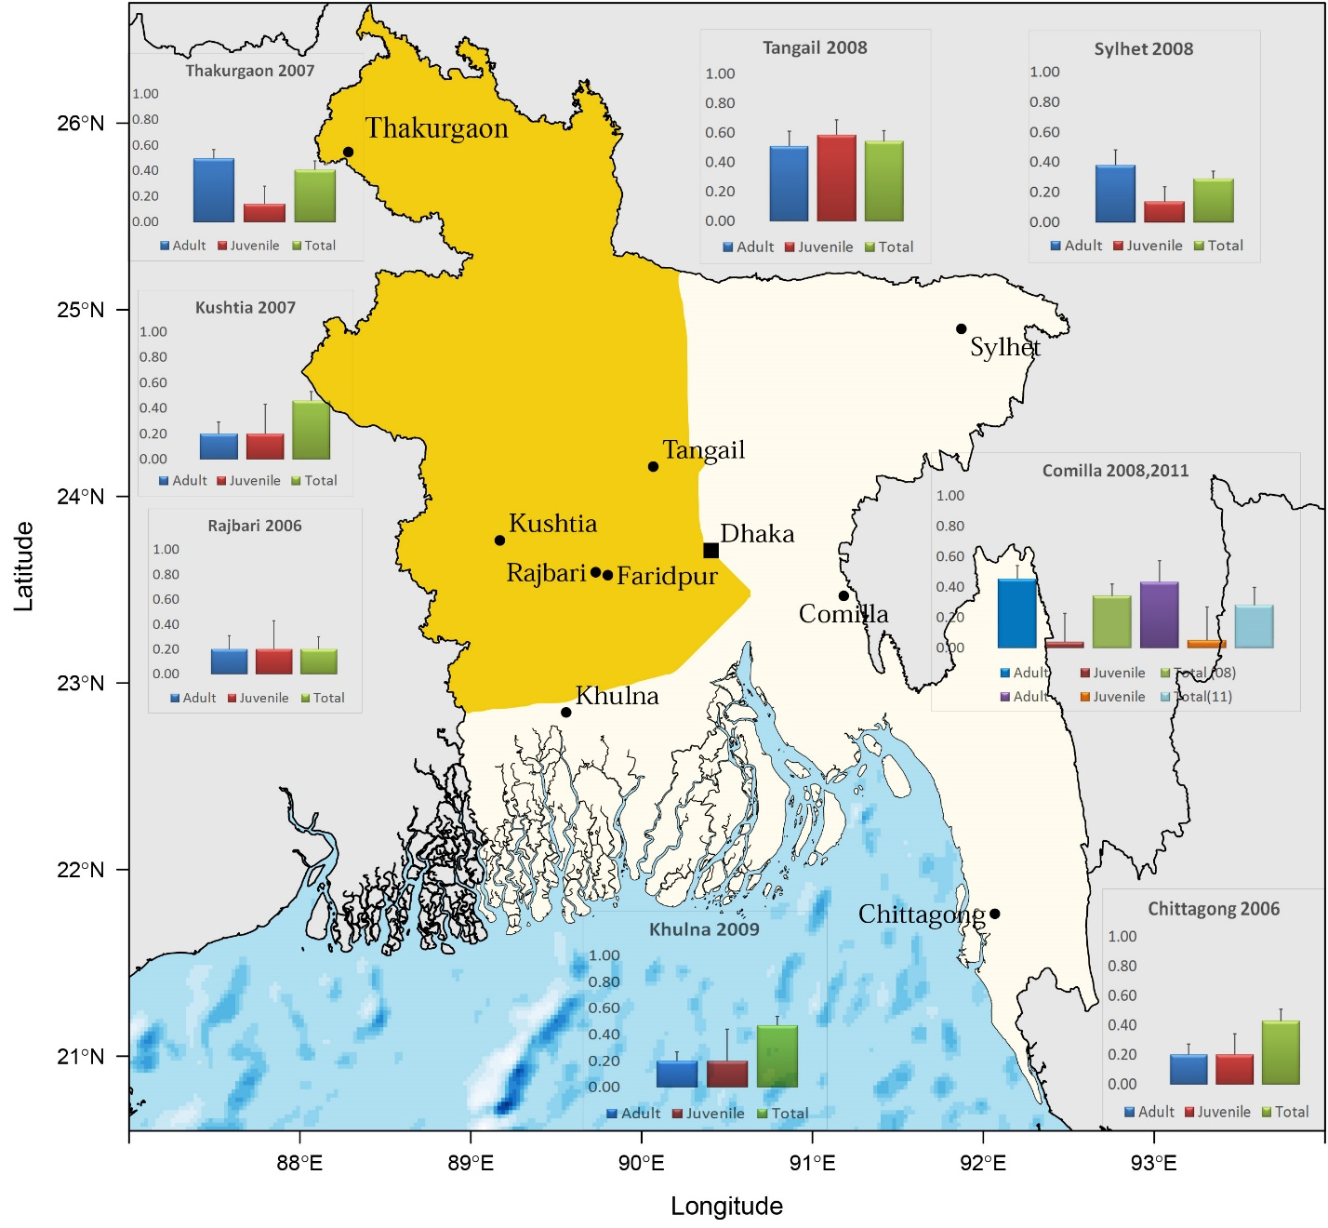

**Figure 1. Map showing age-stratified seroprevalence in *Pteropus giganteus* colonies*,* Bangladesh.** Bats from eight colonies were sampled and tested for anti-NiV IgG antibodies: four within the “Nipah Belt” (orange shaded) and four outside. Seroprevalence of adults (blue, purple), juveniles (red, orange) and total seroprevalence (green, light blue) are shown. Number (n) of Adult, Juvenile, and Total bats sampled (clockwise): Tangail [53,41,94], Sylhet [63, 37, 100], Comilla 2008 [73,27,100], Comilla 2011 [30,20,50], Chittagong [72,24,96], Khulna[85,15,100], Rajbari [65,15, 80], Kushtia [64,36,100], Thakurgaon [89,29,118]. The shaded region represents the “Nipah Belt” where previous outbreaks have been reported. There was no statistical difference between NiV IgG seroprevalence inside the Nipah Belt and outside. Adult bats had equal or greater seroprevalence than juveniles in each location.

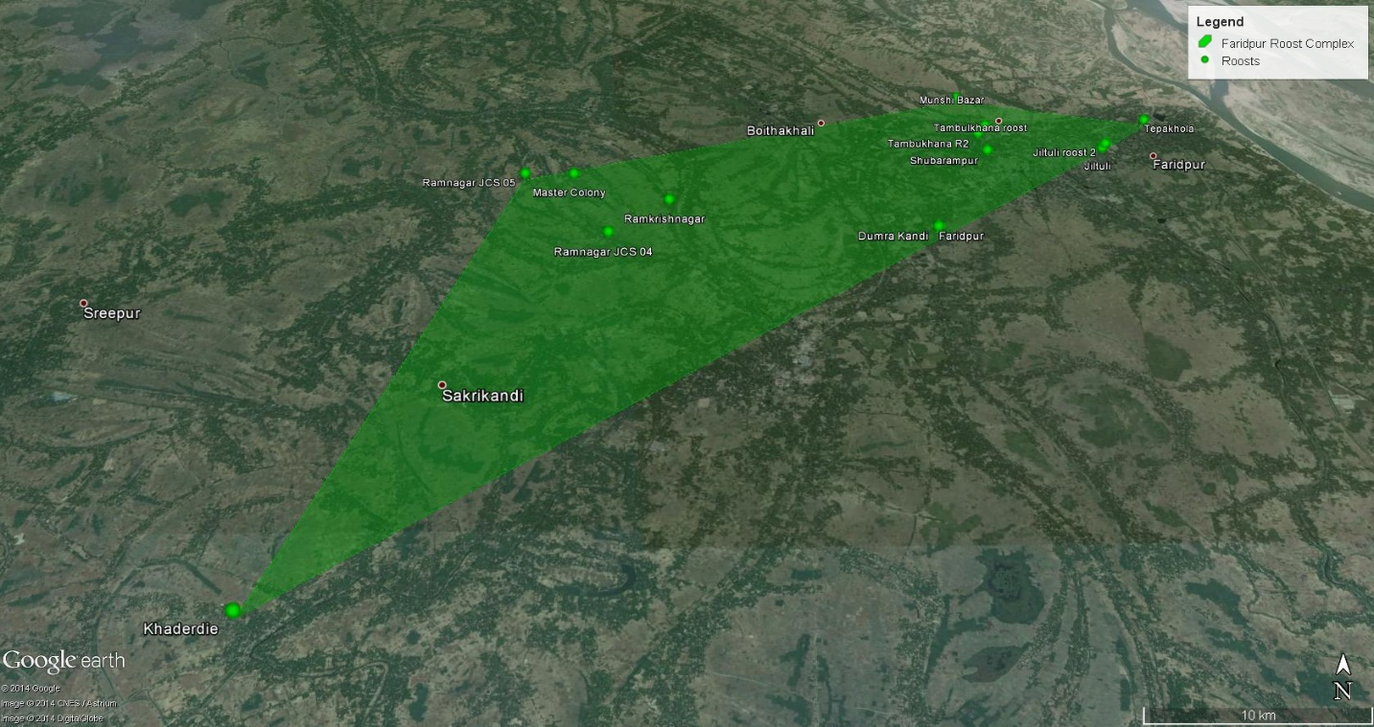**Figure 2**. Faridpur Roost Complex. 51 Individual bats were recaptured during the longitudinal study at various locations. 33 were captured at a site other than where they were originally marked, indicating that local roost shifting occurs. 15 unique roosts within an 80km2 area were identified. This study provides evidence that there is localized roost shifting, and that a single *Pteropus giganteus* populations extends beyond a single roost site.

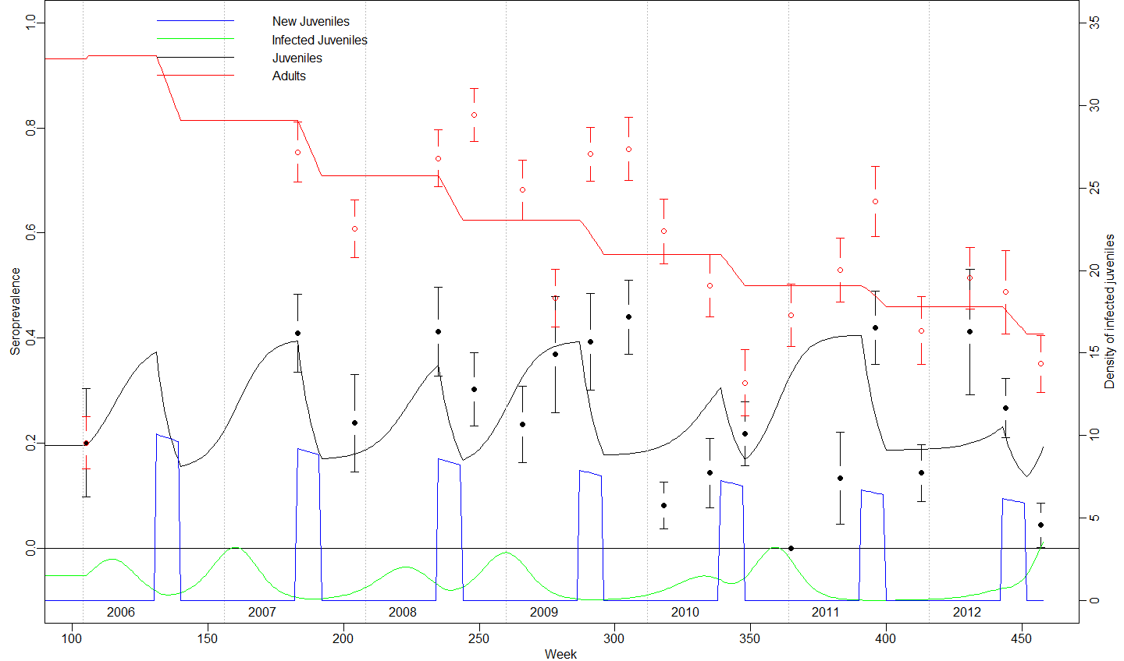

**Figure 3**. Modeled (solid red and black lines) and estimated (red and black circles ±1SE) seroprevalence (right axis), and modeled number of seronegative juveniles joining the sampling population (solid blue line) and density of infected juveniles (solid green line) (right axis) of *Pteropus giganteus* in Faridpur, Bangladesh. Model fit by trajectory matching to adult and juvenile data simultaneously, using a simple SIR structure and allowing for cross-age transmission (but estimated beta parameters for cross age transmission was ~0). Juveniles are assumed to age into adult class after two years.

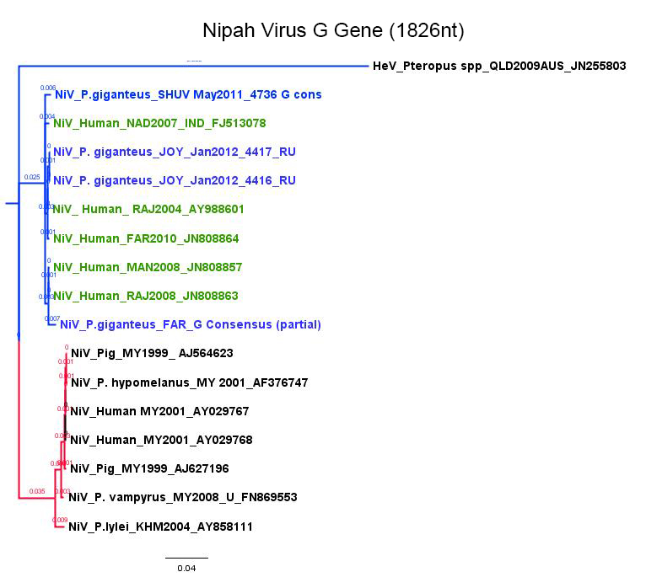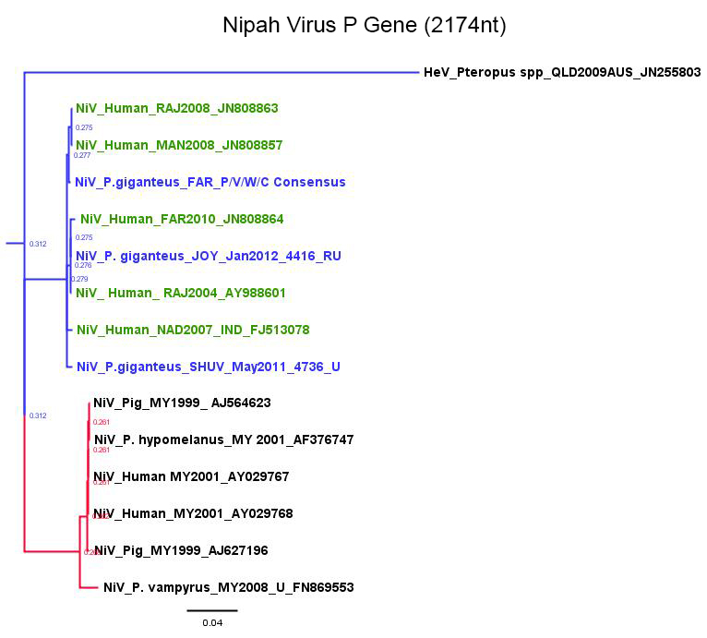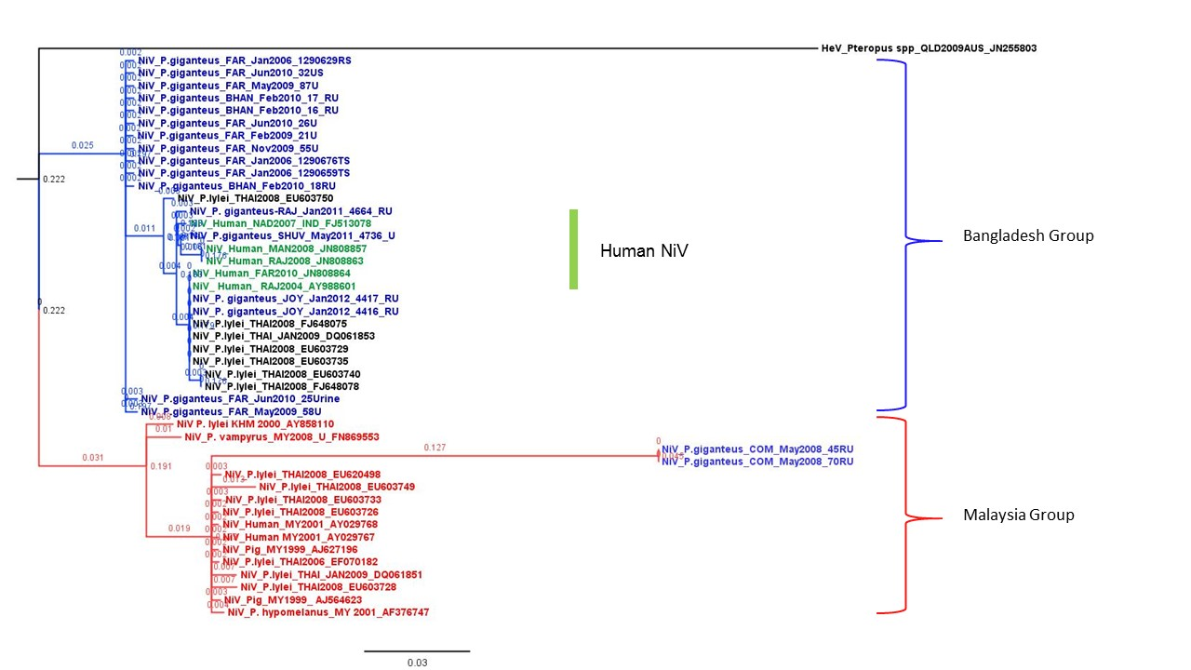

Nipah Virus N Gene (224nt)

A.

B.

C.

**Figure 4 (A-C)**. **Nipah Virus phylogenetic trees:** Clustal W alignments on N (220nt), G (1826 nt) and P (2174 nt) gene sequences done using Geneious 7.1. Genbank accession numbers are included in the label for each sequence. *Pteropus giganteus* sequences from this study are shown in blue. Human sequences from Bangladesh are shown in green. Other sequences from bats, pigs and humans in Malaysia, Thailand, and Cambodia are in black or red. **A.** N gene sequences from *P. giganteus* in Faridpur show stability between 2006 and 2012. Human sequences and other *P. giganteus* sequences obtained from different locations over roughly the same period show more variability. NiV sequence detected in *P. giganteus* from Comilla (150km east of Faridpur) showed ~20% divergence from the Faridpur sequences and clustered within the Malaysia group. **4B** and **4C**. Phylogenetic trees using nearly complete gene sequences for G and P sequences obtained from individual bat and roost urine samples. Both gene regions support the phylogenetic relationships observed in the much shorter N gene region.

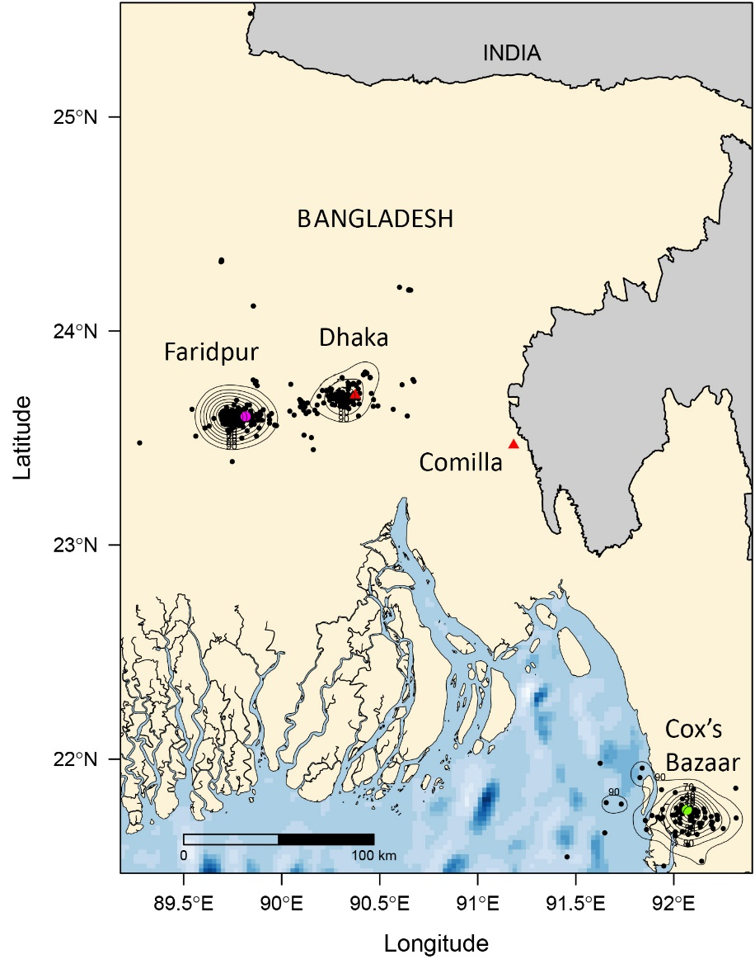

**Figure 5.** Satellite telemetry and homerange. Location data from satellite collars placed on 11 bats from Faridpur and 3 bats from Cox’s Bazaar, Chittagong collected between 2009 and 2011, were used to calculate local and long-range movement patterns and home range for these two groups. *P giganteus* spent the majority of time within a 10km radius of its roost in Faridpur and 7kmin Cox’s Bazaar. Homerange analysis suggests that the probability of migration between colonies in Faridpur and Comilla is low, which could explain the highly divergent strain of Nipah virus detected in Comilla compared to the strains found in Faridpur.

**Table 1**. PCR detection of Nipah virus RNA in *Pteropus giganteus* 2006-2012. 

*NiV RNA was detected in three pooled throat samples, confirmed by sequencing, although confirmation could not be made when individual samples were tested. These data re not used in prevalence estimates.

 Detection by qPCR, Ct ranges 20-38.

Table 2. Recaptured bats and Nipah Virus IgG sero-status from the Faridpur population



Location Codes: Location codes: Jhiltuli (JH); Jiltuli Roost 2 (JH2); Shuvarampur (SH); RamnagarMC (RM); Tepakhola (TP); Ramnagar Roost JCS (RM_JCS); Ramnagar JCS 1 (RM_JCS1); Ramnagar JCS 02 (RM_JCS2); Tambukhana R2 (TB2); Domrakhandi (DM); Khaderdi (KD); Ramkrishnagar (RK); Tepakhola Master Colony ( TPMC). Status Change: C = seroconversion, N = No Change, R = sero-reversion.

Table 2 (cont…). Recaptured bats and Nipah Virus IgG sero-status from the Faridpur population



Location Codes: Location codes: Jhiltuli (JH); Jiltuli Roost 2 (JH2); Shuvarampur (SH); RamnagarMC (RM); Tepakhola (TP); Ramnagar Roost JCS (RM_JCS); Ramnagar JCS 1 (RM_JCS1); Ramnagar JCS 02 (RM_JCS2); Tambukhana R2 (TB2); Domrakhandi (DM); Khaderdi (KD); Ramkrishnagar (RK); Tepakhola Master Colony ( TPMC). Status Change: C = seroconversion, N = No Change, R = sero-reversion.

Supplemental data/figures:

1) Telemetry: Google Earth map showing all bat data points used in analysis

2) image of collar on bat

2) Table of data points used for homerange calculations

3) SIR model code

4) SIR parameters

5) GLM models / definition of factors